London House Price Project — Plan & Instructions
Oct 25, 2026 · @Curtis

Overview
In four weeks (26 Oct – 22 Nov 2026) turn the Land Registry CSV into one GitHub project that proves SQL, Python, ML and BI end to end, with a CV-ready checkpoint after week 2. Budget roughly 8–10 hours a week around applications.
The question the project answers: what drives London house prices, and how accurately can a sale price be predicted from location, property type, tenure and timing?
Skill | What the project proves | Evidence a recruiter sees
SQL | Loading 1M+ rows, cleaning, window functions, CTEs, aggregation | sql/ folder of named, commented queries
Python | Pandas EDA, joining external data, feature engineering | Clean notebooks + a reusable src/ module
ML | Baselines, gradient boosting, time-based validation, SHAP | Model comparison table, error by borough
BI | KPI design for non-technical users | Published dashboard link + screenshots in README
Final deliverables: a public GitHub repo with README, a published dashboard, a 1-page findings summary, and 2–3 CV bullets with real numbers.

4-week schedule
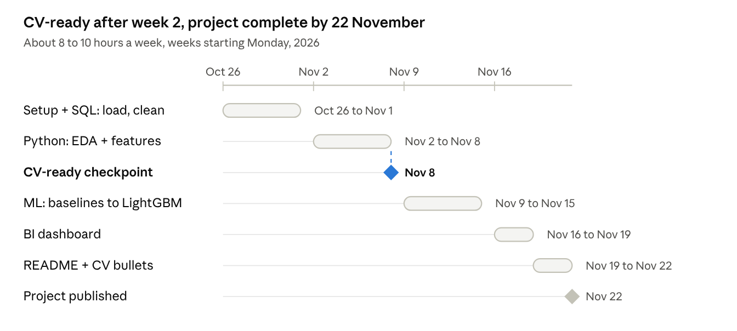
4-week schedule · 5 phases, 2 milestones
One phase per week; BI and packaging share week 4. At the 8 Nov checkpoint the project can go on applications with real SQL and EDA findings.

Setup (Day 1, about 2 hours)
Use DuckDB for SQL: it queries the raw CSV directly, handles the full 5 GB file on a laptop, and is real ANSI SQL you can talk about in interviews.
- Create a Python environment and install: pip install duckdb pandas numpy scikit-learn lightgbm shap matplotlib seaborn jupyter pyarrow
- Create a public GitHub repo, e.g. london-house-prices, and add data/ to .gitignore (never commit the CSV).
- Set up this folder structure:
london-house-prices/
├── data/raw/ # pp-*.csv (gitignored)
├── data/processed/ # parquet outputs (gitignored)
├── sql/ # 01_load.sql, 02_clean.sql, 03_analysis.sql
├── notebooks/ # 01_eda.ipynb, 02_features.ipynb, 03_model.ipynb
├── src/ # features.py, train.py
├── dashboard/ # .pbix or screenshots
├── reports/figures/
└── README.md
- Check which file you downloaded. The complete file is pp-complete.csv (about 30M rows, all of England and Wales since 1995). It has no header row; the 16 columns, in order, are: transaction_id, price, date_of_transfer, postcode, property_type (D/S/T/F/O), old_new (Y/N), duration (F/L), paon, saon, street, locality, town_city, district, county, ppd_category (A/B), record_status.
- Commit after every working session with a meaningful message. A steady commit history is itself evidence.

Phase 1 — SQL: load, clean, analyse (Week 1)
Goal: a clean London table in Parquet plus 8–10 analysis queries whose results go straight into the README.
1. Load (sql/01_load.sql)
CREATE TABLE ppd_raw AS
SELECT * FROM read_csv('data/raw/pp-complete.csv', header = false,
columns = {
'transaction_id':'VARCHAR','price':'INTEGER','date_of_transfer':'TIMESTAMP',
'postcode':'VARCHAR','property_type':'VARCHAR','old_new':'VARCHAR',
'duration':'VARCHAR','paon':'VARCHAR','saon':'VARCHAR','street':'VARCHAR',
'locality':'VARCHAR','town_city':'VARCHAR','district':'VARCHAR',
'county':'VARCHAR','ppd_category':'VARCHAR','record_status':'VARCHAR'});
2. Clean (sql/02_clean.sql) — create london_sales and record the row count lost at each step (this table goes in the README):
- Keep county = 'GREATER LONDON'.
- Keep ppd_category = 'A' (standard market sales; B covers repossessions and bulk transfers).
- Drop property_type = 'O' (Other).
- Keep 2015 onward to keep the size manageable and the market comparable.
- Remove duplicates on transaction_id and blank postcodes.
- Flag outliers rather than deleting blindly, e.g. price below £10k or above the 99.9th percentile.
- Derive postcode_district (e.g. SW11) and postcode_sector (e.g. SW11 2) with string functions.
- Export: COPY london_sales TO 'data/processed/london_sales.parquet' (FORMAT PARQUET);
3. Analyse (sql/03_analysis.sql) — each query has a comment stating the question it answers:
- Median price by borough (district) and year, using MEDIAN() with GROUP BY.
- Year-on-year change per borough with LAG() over a window.
- Top 10 and bottom 10 postcode districts by median price, using RANK().
- Monthly sales volume, showing the 2021 stamp duty holiday spike and the post-2022 rate-rise slowdown.
- Flats versus houses: median price and share of sales by borough.
- New-build premium: new versus existing median within the same postcode district.
- Leasehold versus freehold gap within the same property type.
- 12-month rolling median per borough with a window frame (ROWS BETWEEN 11 PRECEDING AND CURRENT ROW) on monthly aggregates.
- Repeat sales: the same address (postcode + paon + saon) sold twice, and annualised growth between sales. This is the strongest SQL showcase: self-join plus CTEs.
Save each result as CSV in reports/ — these become dashboard sources and README numbers.

Phase 2 — Python: EDA and features (Week 2)
Goal: understand the data visually and build a model-ready feature table. Read the Parquet file with Pandas; it loads in seconds.
EDA (notebooks/01_eda.ipynb) — six charts, each with a one-line takeaway written under it:
- Price distribution, raw versus log scale (motivates predicting log(price)).
- Median price trend 2015–2025 by property type.
- Borough map or ranked bar chart of median price.
- Seasonality: sales volume by month.
- Price per property type across inner and outer London.
- Missing values and outlier summary.
Enrich with one external dataset (pick one; keep it to one):
- ONS Postcode Directory (ONSPD) — adds latitude, longitude and LSOA per postcode. Recommended: location coordinates usually improve a house-price model substantially, and the join is a clean SQL/Pandas exercise.
- Index of Multiple Deprivation joined on LSOA — adds a neighbourhood score (needs ONSPD first).
- Bank of England base rate, monthly — lets you discuss rates versus prices.
Features (src/features.py) — write as functions, not loose notebook cells:
- Categorical: property_type, old_new, duration, district.
- Time: year, month, months since Jan 2015.
- Location: lat/long, postcode district.
- Local price level: median price of the postcode sector in the previous 12 months, computed only from earlier sales. This is your strongest feature and your strongest leakage risk; explain it in the README.
Checkpoint, Sun 8 Nov: SQL and EDA are done with real numbers. You can now list the project on the CV and in cover letters using only findings you actually have.

Phase 3 — ML: predict sale price (Week 3)
Goal: a model compared honestly against simple baselines, validated on future data, with errors explained.
Validation — do this first. Split by time, not randomly: train on 2015–2022, validate on 2023, test on 2024–2025. A random split lets the model see the future, which interviewers will ask about. This mirrors your battery work: train on one regime, test out-of-sample on another.
Target: log(price); convert predictions back to pounds before reporting errors.
Models, in this order (notebooks/03_model.ipynb, final code in src/train.py):
- Baseline A: predict the training median for the borough and property type.
- Baseline B: previous-12-month median of the postcode sector.
- Linear regression (Ridge) with one-hot categoricals.
- Random Forest.
- LightGBM (or XGBoost), tuned lightly on the 2023 validation year.
Metrics, in one comparison table: MAE (£), median absolute percentage error, RMSE on log price, R². Median percentage error is the most intuitive for a non-technical reader ("typically within X% of the sale price").
Explain the model:
- SHAP summary plot: which features drive price.
- Error by borough and property type: where the model struggles (expect flats in prime central boroughs and new builds).
- Error over time across the test period: does accuracy decay as the market moves?
Write one honest limitations paragraph: no floor area, number of rooms or condition in this data. Adding EPC floor area is a natural future step.

Phase 4 — BI dashboard (Week 4, first half)
Goal: a 3-page dashboard a non-technical manager can use in two minutes. Use Power BI Desktop (free, Windows; most requested in UK analyst roles) or Tableau Public (free, Mac or Windows, gives a public link). QuickSight is already on your CV from AWS, so a second tool widens your range.
Feed it the aggregated CSVs from Phase 1 and the model predictions from Phase 3, not the raw 30M-row file.
Page | KPI cards | Visuals | Filters
Market overview | Median price, sales volume, YoY change | 12-month rolling median line, monthly volume bars | Year, property type
Borough explorer | Borough median, rank, new-build premium | Borough map or ranked bars, flats vs houses split | Borough, tenure
Model insights | Median % error, share within ±10% | Predicted vs actual scatter, error by borough, top SHAP features | Borough, property type
Design rules: one question per page, titles that state the finding ("Outer London grew faster than inner since 2020"), consistent colours, and a short "how to use" note. Export three screenshots for the README.

Phase 5 — Package it (Week 4, second half)
Goal: a recruiter understands the project in 60 seconds and an interviewer can go deep for 20 minutes.
README structure: one-line summary → key findings (3 bullets with numbers) → dashboard screenshots and link → data and cleaning table (rows kept at each step) → SQL highlights (link the repeat-sales query) → model comparison table → limitations and next steps → how to reproduce.
CV bullet templates — fill in only with numbers you actually produced:
- Built a DuckDB SQL pipeline cleaning [N]M HM Land Registry transactions into an analysis-ready London dataset, using window functions and CTEs to measure borough price trends and repeat-sale growth.
- Engineered location and time features in Python (Pandas, ONS postcode data) and benchmarked 5 models with time-based validation; LightGBM predicted 2024–25 sale prices within [X]% median error, versus [Y]% for a borough-median baseline.
- Designed a 3-page Power BI dashboard on London price trends and model accuracy for non-technical users.
Interview talking points to prepare:
- Why a time-based split, and what leakage you avoided in the local-price feature.
- Why log price, and why median rather than mean.
- Where the model fails and what data would fix it (floor area via EPC).
- One surprising finding from the SQL analysis.

Pitfalls and done checklist
The three mistakes that most weaken this kind of project: a random train/test split, a local-price feature computed with future sales, and opening the 5 GB CSV in Excel or plain Pandas.
- ☐ Raw CSV gitignored; repo is public with a clear README
- ☐ Cleaning steps and rows removed documented in a table
- ☐ 8–10 SQL queries, each answering a stated question
- ☐ 6 EDA charts with one-line takeaways
- ☐ One external dataset joined (ONSPD recommended)
- ☐ Time-based split; no feature uses future data
- ☐ Baselines beaten, with a model comparison table
- ☐ SHAP plot and error-by-borough analysis
- ☐ 3-page dashboard published, screenshots in README
- ☐ CV bullets updated with real numbers only
If a week slips, cut scope rather than quality: drop the Random Forest and the third dashboard page before dropping the baselines or the time-based split.

